Name:__________________________
Directions: Complete your table by doing the following: fill in the date for each event, and in the last column, describe how each event helped to shape American rights and government. The first row has been done for you.
Event | Date | Icon | Effect on American Rights and Government
Magna Carta | 1215CE | This Photo by Unknown Author is licensed under CC BY | It began to create the right to due process of law. It supported the principle of no taxation without representation, said the king wasn’t above the law, and helped establish a representative government.
English Bill of Rights |  | 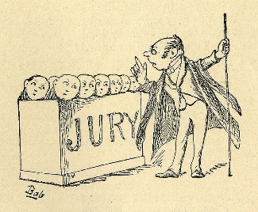
House of Burgesses |  | 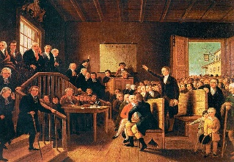
Albany Plan of Union |  | 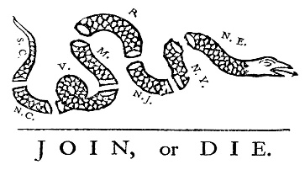
Act of Religious Toleration
Zenger Trial |  | 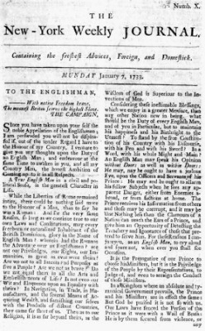
Great Awakening |  | 